English Seminar Name: _____________
DIRECTIONS: Consider how Vonnegut sets up a turn, where the story actually turns, what this means analytically, and how Vonnegut makes a claim based on this structural decision.

Characters | Select a quote that sets up a turn in the story. | Find a quote where the actual turn takes place. | Analysis of Quotes | Vonnegut’s claim?
Doctor Remenzel

Sylvia Remenzel

Other

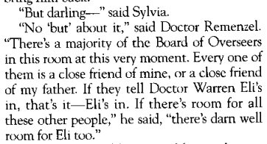

English Seminar Name: _____________
In Kurt Vonnegut’s short story, “The Lie”, there are several important turns. A turn is a rhetorical shift or dramatic change in thought and/or emotion. Look at the model below and consider how these quotes equate to one of Vonnegut’s claims.

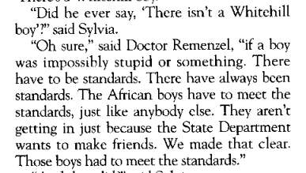
The Set Up The Turn

Analysis of Quotes | Vonnegut’s claim?

